**Task 1. Create an S3 bucket**

**Start Lab – Aws icon (yellow) – green**

**Services – Storage – S3**

* **Create Bucket – Bucket name – Dhrishbucket**
* **Region ( Mumbai )**

## Graphical user interface, text, application, email Description automatically generatedTask 2. Add a bucket policy to make the content publicly available

Create bucket – click on dhrishbucket – Permissions – Type the required code

{

"Version": "2012-10-17",

"Statement": [

{

"Sid": "PublicReadGetObject",

"Effect": "Allow",

"Principal": "*",

"Action": "s3:GetObject",

"Resource": "arn:aws:s3:::dhrishbucket/*"

}

]

}

Now click on Save Changes

## Task 3. Upload an HTML document

Save Index.html

Objects – upload the file here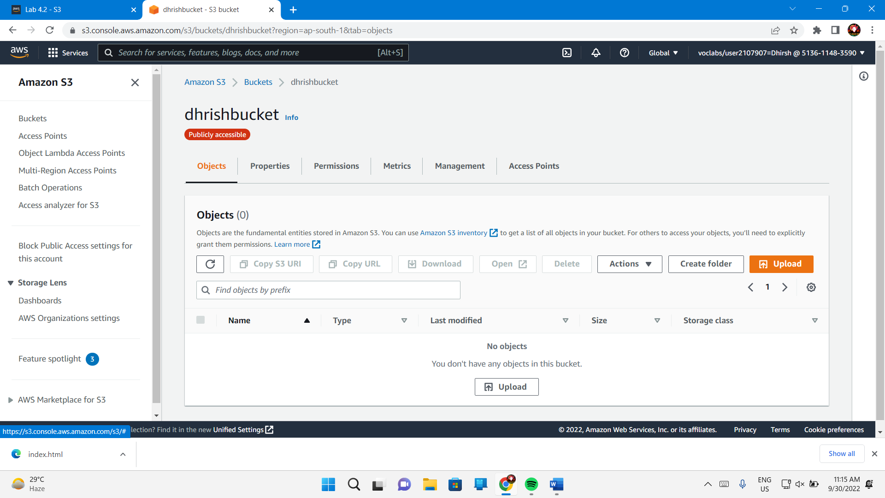

Properties – Standard

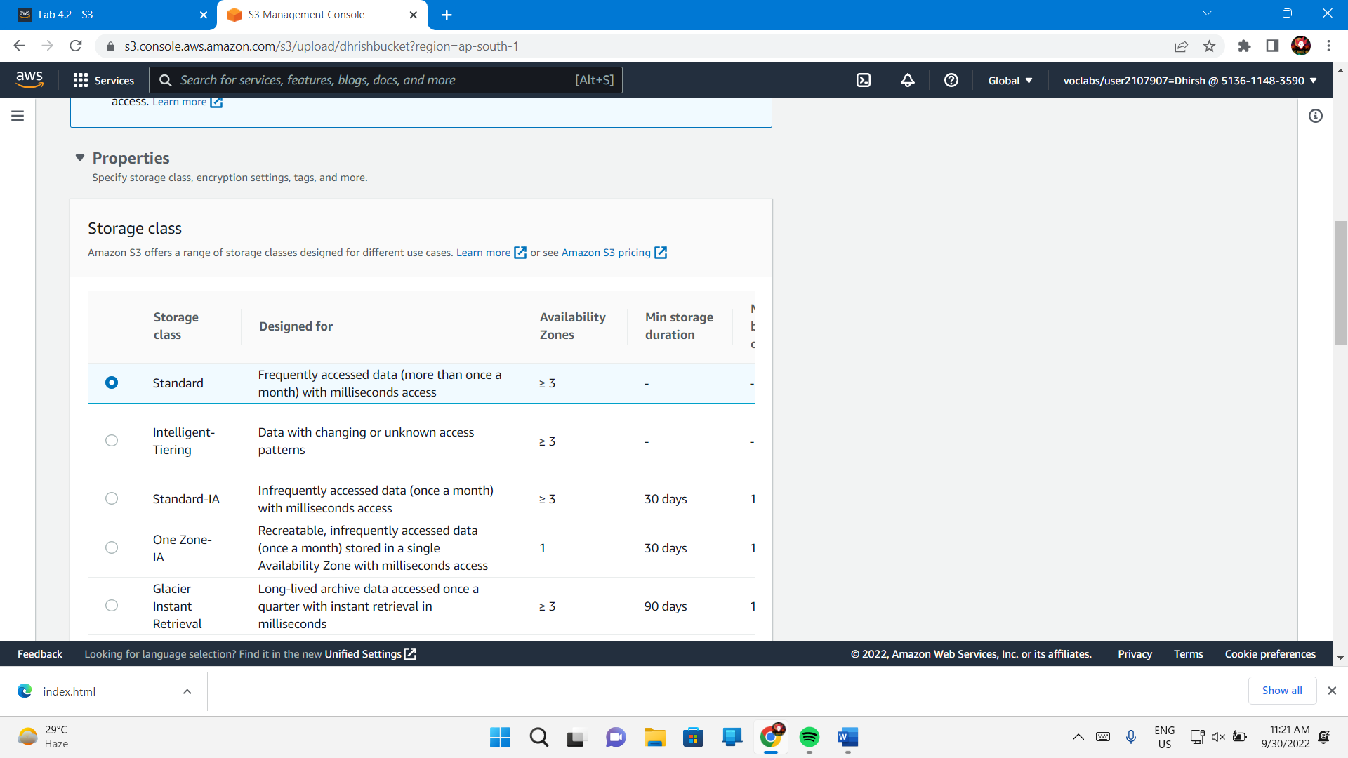

Now click in upload

Close

## Task 4. Test your website

Now go to properties tab

Static website hosting

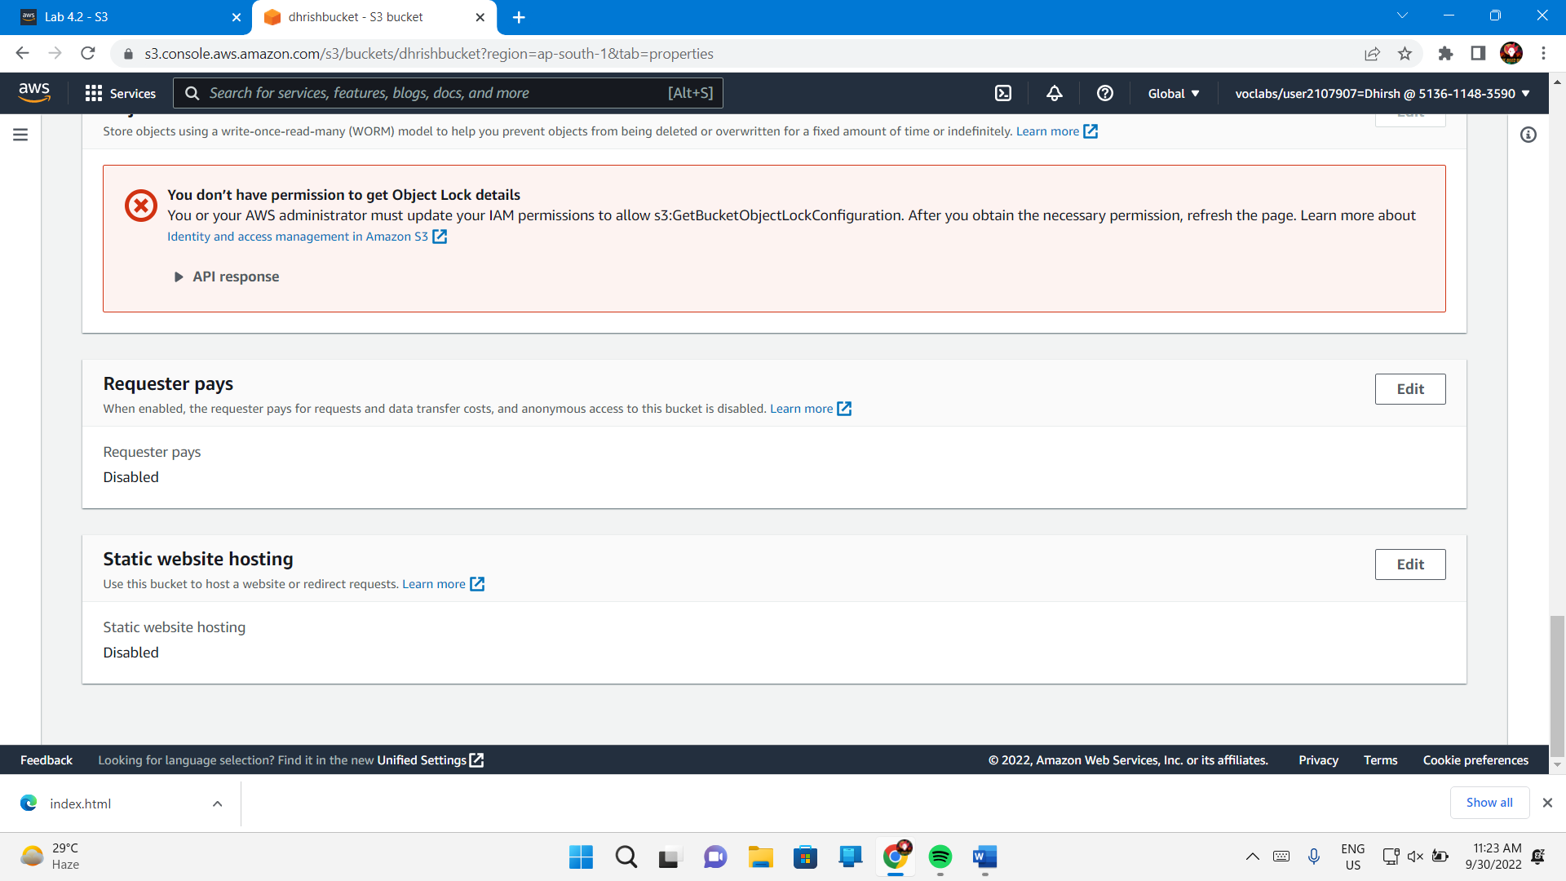

Click on edit-enable

Static website hosting – Enable

Index document – index.html

Save changes

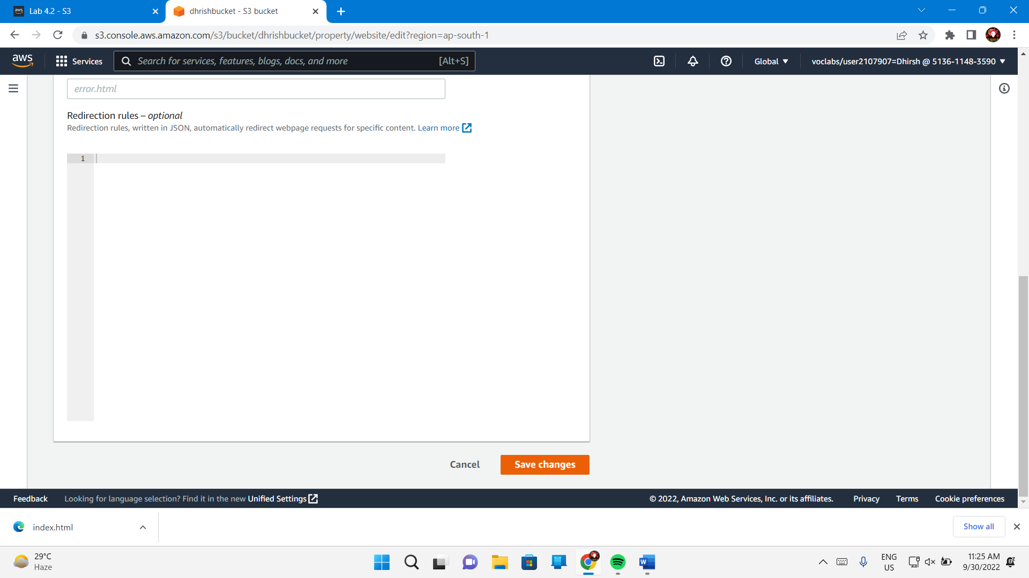

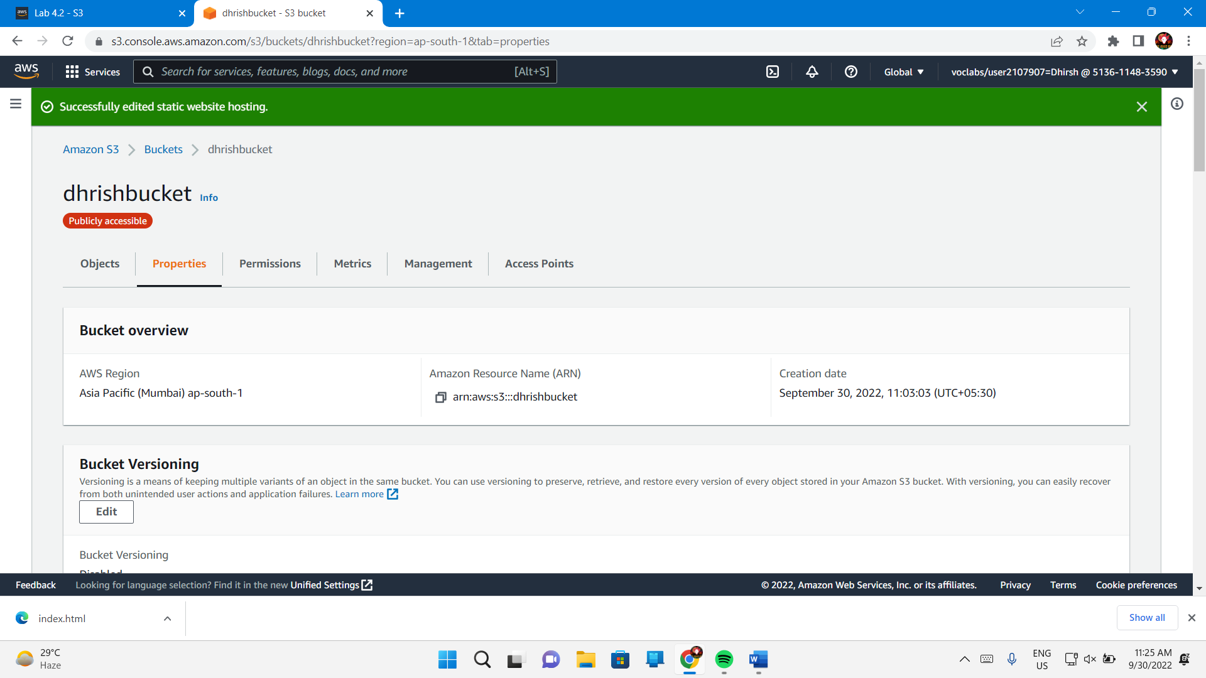

Copy the url under static website hosting

Open the url in a new tab

Now signout

End lab – yes



